**REPORT ON ANALYSIS OF FLIPKART REFRIGERATOR CSV:**

THE MAIN AIM OF THIS ACTIVITY IS TO ANALYSE THE REFRIGERATOR DATASET AND INTURN PERFORM THE MULTIVARIATE LINEAR REGRESSION TO PREDICT THE MRP OF A SPECIFIC REFRIGERATOR BASED ON VARIOUS PARAMETERS.

**Techniques Used**

* Data Analysis & Data Visualization

**DATASET:**

FLIPKART REFRIGERATOR DATASET

**SAMPLE DATA:**

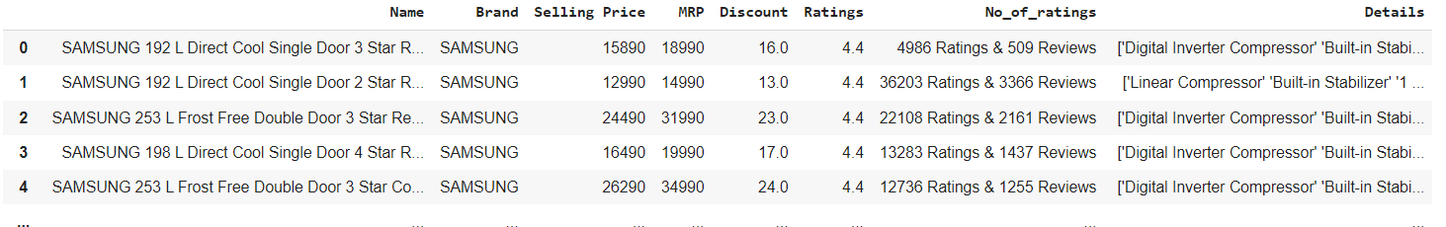

**Libraries Used**

* Numpy
* Pandas
* Matplotlib
* Seaborn

PLOTING THE COUNT PLOT FOR VARIOUS BRANDS

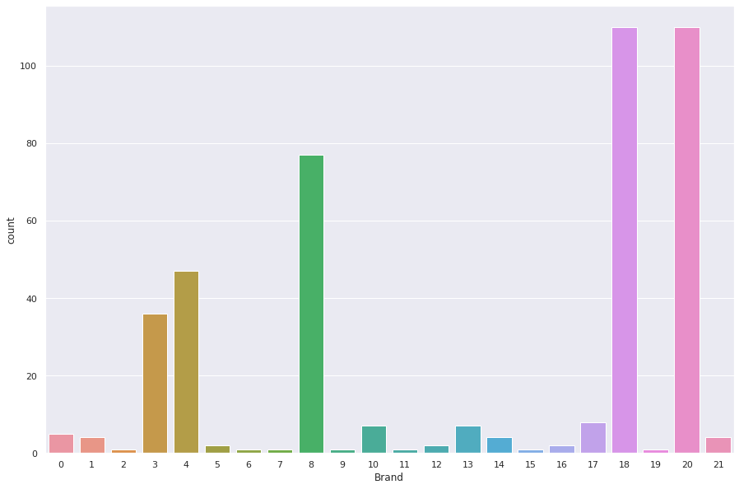

A RELATIONAL PLOT BETWEEN MRP AND SELLING PLOT IS PLOTTED TO GET A GLIMPSE OF DATA:

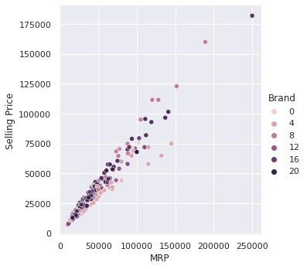

LINE PLOT FOR RELATION BETWEEN BRAND AND RATINGS

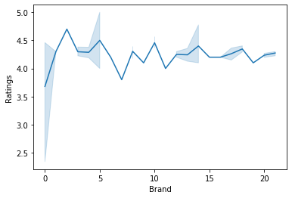

LINE PLOT FOR RELATION BETWEEN BRAND AND MRP

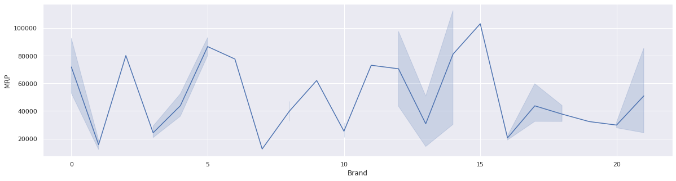

LINE PLOT FOR RELATION BETWEEN BRAND AND DISCOUNT

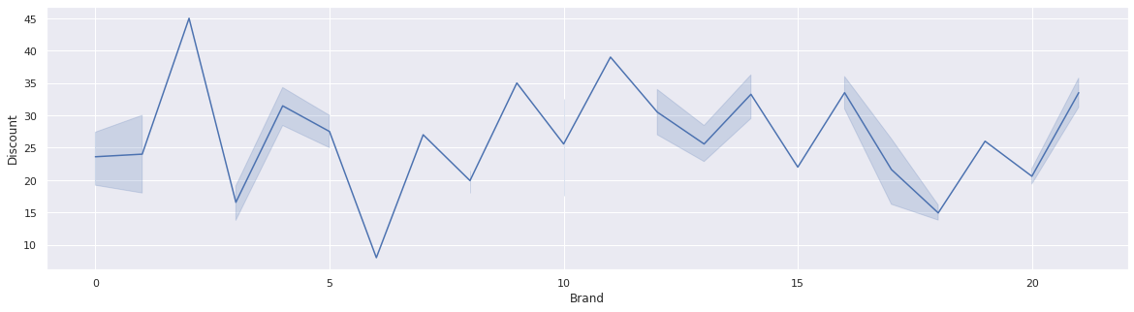

PAIRPLOTS OR CORELATING

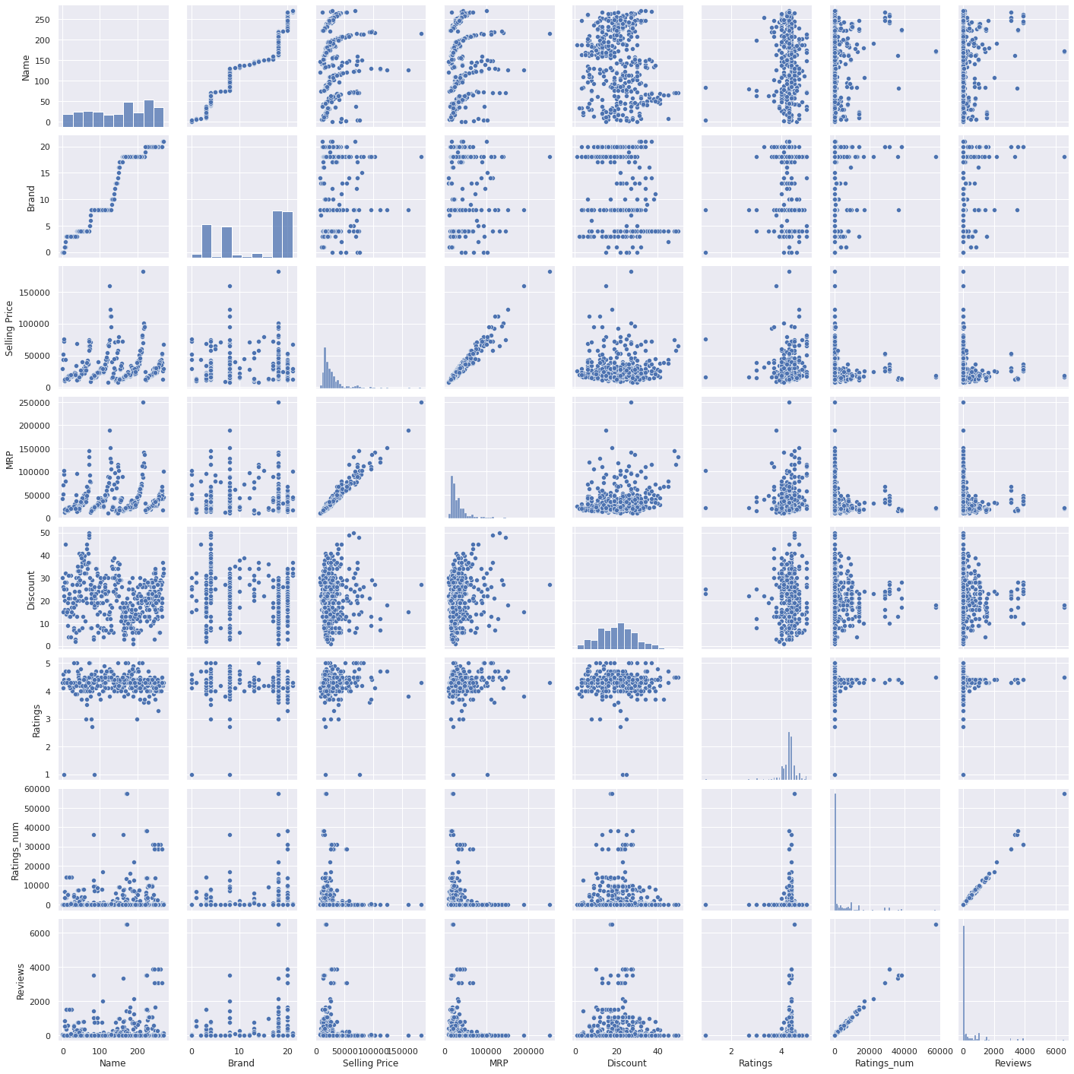

USING LABEL ENCODING AND DROPPING IRREVELANT COLUMNS

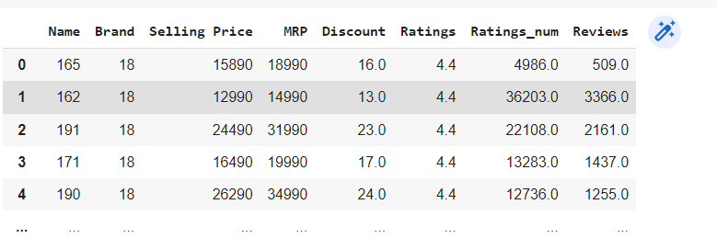

APPLYING LINEAR REGRESSION (MULTIVARIATE) AND CHECKING THE REAL SCORE

reg = linear_model.LinearRegression()

reg.fit(data.drop('MRP',axis='columns'),data.MRP)

**CHECKING ACCURACY**

0.9817005265765404